|  |
| --- |
| *CometBites* |
| **Cloud Architecture** |
| **SE 6387 Advanced Software Engineering Project**  **R.Z. Wenkstern**    ***11/14/2016*** |

|  |
| --- |
| **Group *CometBites*** |
| **Ronaldo Goncalves Junior**  **rxp152830** |
| **Twinkle Sharma**  **txs151730** |
| **Keerthi Santhalingam**  **kxs142830** |
| **Ramakrishnan Sathyavageeswaran**  **rxs142530** |

# 1. Cloud setting

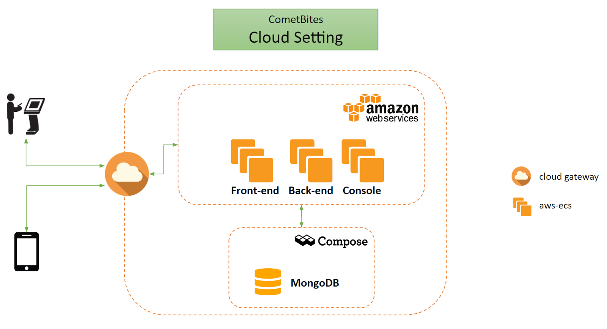

**Figure 1: Overview of the cloud environment.**

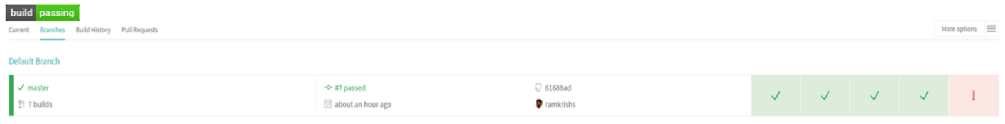

**Figure 2: Build report.**

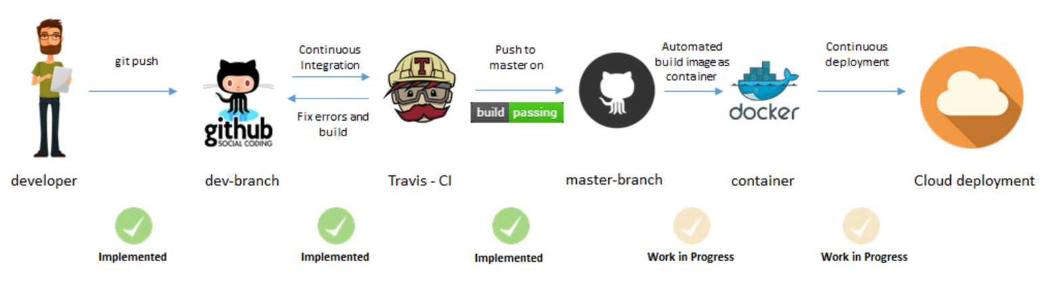

**Figure 3: Continuous Integration and Continuous Deployment workflow.**

# 2. Rationale

Only a limited number of cloud providers were considered in the trade-off analysis. For security purposes, Amazon Web Services was selected as the cloud provider to host CometBites application. Its highly scalability allows the engineers to easily upgrade the servers hardware. Security groups are easy to configure and it is possible to filter ports to the web server which hosts the backend. In addition, the ELB (Elastic Load Balancer) providers an additional layer of protection to the application. It is also important to mention that the team is already experienced in using these services, another reason to select this provider since the project has strict time limitations.

The web servers hosted in the virtual machines are connected a MongoDB database. MongoDB is a good database option because it provides the functionality of storing the data in document-based collections, which allow different values for a same class. For instance, the Card class inside the database might have 4 attributes (name, number, cvv, and expiration date) if it is a credit card, but only 2 (name, and number) if it is a comet card. Finally, we chose to use Compose because it exposes MongoDB as a service and handles the operations internally, using a GUI to provide these features.